Version 9. 2025

LOGISTIC & DELIVERY
GUIDELINES


CONTENT GUIDE

1. INTRODUCTION 3
2. ORDER ACKNOWLEDGEMENT 3
3. CHANGES IN DELIVERY DATES 3
4. PRICE CHANGES 3
5. OPEN ORDER REPORT 3
6. DELIVERY RESPONSIBILITY 3
7. DOCUMENTATION 4
8. COMPLIANCE WITH REQUIREMENTS FOR CONTAINER SIZE / TYPE AND SITE OF MANUFACTURE 6
9. TRANSPORTATION & CARRIER SELECTION 7
10. PALETTIZATION INSTRUCTIONS 7
11. RETURNS 9
12. TAMPER EVIDENT SEAL 9
13. BATCH NUMBERS 9
14. SHELF LIFE REQUIREMENTS 9
15. PALLET STANDARDS 10
16. PACKING LIST & DATA LOGGERS 11
17. LABELING REQUIREMENTS 11
18. SHIPMENT SPECIFICS 17
19. RECEIVING SITES PROCEDURES 17
REMINDER- Non-Conformity Penalties 17
EXHIBIT 1: ONLINE REFERENCE SITES 18
EXHIBIT 2: INCOTERMS 2020 19
EXHIBIT 3: Consignment Data Logger Form 20
EXHIBIT 4: External SharePoint Collaborative Environment – Procedure and User Guide. 21

INTRODUCTION
This handbook outlines the general delivery requirements applicable to all goods shipped to Pharmascience or its subsidiaries. These guidelines shall apply unless superseded by specific provisions in other written agreements, such as Quality Agreements or commercial contracts. In cases where such agreements contain differing instructions, only those specific sections shall override this handbook; all other provisions herein remain in effect.
This document is designed to comply with all applicable Canadian and local regulations. In the event of any conflict or deficiency, the relevant regulatory requirements shall take precedence, and Pharmascience must be notified immediately

ORDER ACKNOWLEDGEMENT
Upon receipt of a Purchase Order (PO) from Pharmascience, the Vendor is expected to confirm the following details via email within 2 to 5 business days:
- Confirmed delivery date to the agreed destination
- Quantity to be delivered
- Price and currency
- Incoterms 2020
- Payment terms
If the Vendor is unable to provide confirmation within the specified timeframe, they must inform the Buyer of the expected date of availability for the acknowledgement.
Any discrepancies in pricing must be resolved prior to shipment. By acknowledging the order, the Vendor confirms acceptance of all terms and conditions outlined in the PO

CHANGES IN DELIVERY DATES
Any changes to the agreed delivery date must be communicated immediately to the Operational Planner (Buyer), along with a clear explanation for the change.
Pharmascience expects Vendors to make reasonable efforts to accommodate requested delivery timelines

PRICE CHANGES
All proposed changes to pricing must be submitted to the Supplier Relationship Manager for review and approval prior to implementation

OPEN ORDER REPORT
Unless otherwise agreed upon, Pharmascience requires Vendors to submit a weekly open order status report. This ensures alignment between both parties’ systems and helps prevent last-minute discrepancies.
Vendors operating under the RPA model should continue using it as their primary communication method.
For Vendors engaged in a Shared Planning Model, reporting frequency and responsibilities will be defined in the applicable Service Level Agreement (SLA).

DELIVERY RESPONSIBILITY
Delivery responsibilities are governed by the Incoterms specified in the PO. If the Incoterms are incorrect, the Vendor must notify the Buyer to ensure alignment with the mutually agreed terms.

DOCUMENTATION
Shipping documents
Shipments arriving without prior submission of documentation may incur storage and additional fees, which will be the responsibility of the shipper.
Electronic copies of all shipping documents must be submitted prior to dispatch via email to:
- grplogistics@pharmascience.com
- Vendor-specific SharePoint site (For contract-manufacturers)
All freight deliveries require scheduled appointments with the designated warehouse contacts. Email is the preferred method for booking. Please allow 24 hours for appointment confirmation.
The Packing List must include:
- Detailed quantity per presentation and total quantity.
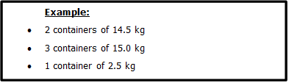

- Individual container listing (handwritten if necessary)
- Unit value and total value (currency must be specified; “0” value is not acceptable for customs)
- Country of origin (manufacturing location, not distribution)
- Incoterms
- Total number of pieces and gross weight
- Transportation conditions (e.g., temperature requirements)
- HS code (customs tariff number)
- Data logger numbers and completed Consignment Data Logger Form
- Manufacturing date

Invoices Submission
To ensure timely processing, please adhere to the following instructions when submitting invoices:
- Format: All invoices must be submitted in PDF format.
- Submission Method: Send invoices via email to Pharmascience’s Accounts Payable department at:
  - appms@pharmascience.com
Email Subject Line Requirements. The subject line must clearly include the following information:
- Company name
- Invoice number
- Purchase Order (PO) number
Please avoid using terms such as “urgent,” “reminder,” “due,” etc. in the subject line to prevent processing delays.
- Other Accounts Payable Requests:
For account statements, please direct your email to:
- accountpayables@pharmascience.com
For all other inquiries, please email:
- APInquiries@pharmasciene.com

Quality Assurance Documents
Documents such as Certificate of Analysis (CoA), Certificate of Manufacture (CoM), or Certificate of Conformity (CoC) must be submitted electronically immediately after the product release or prior shipping.
- Email: cofasupply@pharmascience.com (Royalmount site)
- Email: #DL_Quality_QA_Inspecteurs_CAC@pharmascience.com (Candiac Site)
For Contract Manufacturers (Bulks and Finished Products)
- Upload to the Vendor’s SharePoint folder or via email at: QA_vendors@pharmascience.com
- Upload all documents referenced in CoA, CoC or CoM such as deviations, laboratory investigations, protocols or change controls.
Refer to Exhibit 4 for detailed procedures.
Important:
- Do not combine multiple documents into a single PDF. Each certificate must be submitted as an individual PDF file.
- File naming convention:
DocumentType_BatchNumber_SKUCode_Description_PO#
Vendor performance will be evaluated based on timely and accurate submission of product release documentation
COGS Inventory reports
For Vendors receiving COGS materials on consignment from Pharmascience, actual consumption data must be submitted with each shipment and uploaded to the designated SharePoint folder within 24 hours of receipt.
The report must include:
- Inventory levels (before and after usage)
- Usage details (based on batch records)
- Losses (with explanations)

CONTACT LIST AND ADRESSES

Pharmascience Inc | Address: ROYALMOUNT manufacturing site  6111 Royalmount Montreal,  QC, H4P 2T4, Canada | Address: DORVAL warehouse  1177, 55e Av Dorval  H9P 2W7 Canada | Address: CANDIAC manufacturing site  100, boul. de l'Industrie, Candiac, QC, J5R 1J1, Canada
Logistic contact | grplogistics@pharmascience.com  Phone: +1-438-315-3747
Reception contact | receptionroyalmount@pharmascience.com  Phone: 1 (514) 449-8100 | receptiondorval@pharmascience.com  Phone: 1 (514) 402-6666 | logistics_candiac@pharmascience.com  Phone: 1(438) -985-8362
Custom Clearance | grplogistics@pharmascience.com  Documents: CCI, CUSMA Certificate (USA and Mexico) or Certificate of Origin (other countries), AWB, BOL, Commercial invoice and Packing list
Custom broker | DHL Global Forwarding (Canada) Inc:  Address: 555 Montee de Liesse, St-Laurent, Quebec (H4T 1P5), Canada  Main Phone : + 1 (514) 344-3447  Email: dgfyul.pharma@dhl.com
QA contact (Finished goods & Bulks) | QA_vendors@pharmascience.com
Invoice contact | appms@pharmascience.com
Accounts Inquiries | APInquiries@pharmascience.com
Change control notifications | ccreception@pharmascience.com (Royalmount)  Compliance_CAC@pharmascience.com (Candiac)
COAs ROYALMOUNT | Cofasupply@pharmascience.com
COAs Candiac | #DL_Quality_QA_Inspecteurs_CAC@pharmascience.com

COMPLIANCE WITH REQUIREMENTS FOR CONTAINER SIZE / TYPE AND SITE OF MANUFACTURE
- All materials sold to Pharmascience must adhere to the specified site of manufacture and container size/type requirements as communicated during the sourcing process.
- If the Vendor is unable to meet these specifications, they must contact the Buyer for resolution. Substitutions are strictly prohibited unless pre-authorized in writing by Pharmascience.
- Materials stored in drums must comply with container closure recommendations to ensure product integrity during transportation, handling, and storage. This includes the use of multiple protective bags where applicable.
- Each drum must be clearly labeled with the following information:
  - Storage conditions
  - Batch number
  - Manufacturing and expiry dates
  - Manufacturing site and full address
  - (Refer to Section 17 for labeling standards)
Preferred container specifications:
- Maximum gross weight per container: 22 kg (50 lbs)
- Maximum gross weight per individual drum (solid/liquid): 75 kg (165 lbs)

TRANSPORTATION & CARRIER SELECTION
When Pharmascience is responsible for freight charges, the following guidelines apply for carrier selection:
Overseas Shipments
- For EXW, FCA, and FOB shipments, the Vendor must contact the Pharmascience Logistics Department at grplogistics@pharmascience.com to be assigned an approved freight forwarder who will coordinate the shipment.
U.S. Origin – Palletized Freight
- FAREL INTERNATIONAL
  - Main Contact: Liza Dawson
  - Phone: (450) 491-0010 ext. 224 or 1-800-621-9245 ext. 224
  - Fax: (450) 491-0015
  - Email: Ldawson@farel.com
Envirotainer Shipments (Air Freight)
- Shipments using envirotainers must not arrive between Friday and Saturday, or on the day before a holiday, to avoid weekend storage and additional rental fees. Pharmascience will not be responsible for these charges.
- The airline or handler must provide clear written instructions for the return of empty units. Pharmascience will not assume responsibility for fees resulting from incomplete or inaccurate return instructions.
- All other air freight shipments must also avoid arrival between Friday and Saturday or the day before a holiday due to limited free time at destination airports. Storage charges incurred will be the shipper’s responsibility.
- A reputable freight forwarder must be used for all shipment coordination at both origin and destination.
- All pallets from a single shipment must remain consolidated throughout transit to maintain integrity and traceability

PALETTIZATION INSTRUCTIONS
- Ideally, each pallet should contain only one batch.
- If multiple batches are included on a single pallet, they must be:
  - Clearly segregated
  - Individually identified
  - Separately shrink-wrapped
  - (Exceptions apply only in special cases and must be pre-approved)
- All labels must be:
  - Facing outward
  - Clearly legible through the plastic wrap
- Partial containers must be clearly marked with a “PARTIAL” label, preferably in color, and placed on the top of the container.
  - Example format for labeling will be provided upon request or in the appendix

- The Vendor is responsible for ensuring that all materials are properly packed to arrive at Pharmascience facilities in clean, undamaged, and compliant condition.
- For raw materials packed in bags, the following precautions must be taken:
  - No overhang on the pallet
  - Reinforced corners using cardboard
  - Multiple layers of shrink wrap to secure the load. Shrink wrap must cover the pallet and the entire load.
- All palletized materials must be stabilized using stretch-wrap, straps, or other appropriate methods to prevent shifting during transit.
- If materials arrive in a non-conforming condition, Pharmascience reserves the right to refuse the shipment and return it at the Vendor’s expense.
- Shrink-wrapped products must be shipped in accordance with the approved Pharmascience specifications.
- Bulk materials must be packed in opaque plastic drums, securely sealed to maintain product integrity.
- For finished goods, ensure that all cases are properly filled and packed to minimize internal movement and prevent damage during transportation, as per example below:
- Finished goods must be packaged and shipped in accordance with the approved Pharmascience specifications.
- For airfreight shipments, all pallets must be wrapped using thermo wrapping or thermo foil to protect against temperature fluctuations.
  - Double wrapping is required when temperatures at the origin or destination exceed 30°C, to ensure product stability and compliance with transport standards.

RETURNS
- For sub-contractor material returns, a compliance certification form (form available upon request) must be filled and sent to the supply chain group (#DL_SUPLCHN_ThirdPartySupplyChain_RMT@pharmascience.com) or to the supply chain analyst responsible for the account.
- Raw materials and packaging components return must be sent to our Royalmount facility. Finished goods returns must be sent to our Dorval warehouse.
- Returns must be authorized in advance by the Supply Chain team, and a valid Purchase Order (PO) must be issued before proceeding.
- Returned goods must be placed on a separate pallet, clearly segregated from finished products.
- All return shipments must include a data logger or be transported in a temperature-controlled truck equipped with a temperature chart to ensure traceability and compliance.

TAMPER EVIDENT SEAL
- Each container must be equipped with a tamper-evident seal to ensure that the material has not been compromised during transit.
- The seal must be intact upon arrival at Pharmascience. Any evidence of tampering may result in rejection of the shipment.

BATCH NUMBERS
- Materials should ideally be supplied from a single batch number per Purchase Order, delivered in one consolidated shipment.
- If multiple batches are required, prior written authorization must be obtained from Pharmascience

SHELF LIFE REQUIREMENTS
- Products shipped to Pharmascience must have at least 75% of their remaining shelf life or retest period at the time of delivery.
- Shipments that do not meet this requirement must be pre-authorized by the Buyer in writing.
- Non-compliant shelf life may result in rejection of the goods and return at the Vendor’s expense

PALLET STANDARDS
- All shipments must be delivered on heat-treated wooden pallets that meet the following specifications
Metric Dimensions:
- Size: 102 cm x 122 cm x 10 cm
- Weight: 12 kg
Imperial Dimensions:
- Size: 40 in x 48 in x 4 in
- Weight: 25 lbs
- Pallets must be 4-way accessible, allowing forklift entry from all sides.
- Maximum allowable weight per pallet: 1100 kg / 2500 lbs
- Maximum allowable height including inventory: 132 cm / 52 in

- If, in exceptional cases, the Vendor intends to use alternative pallet types (e.g., plastic or cardboard), prior approval must be obtained by contacting the Pharmascience Logistics Department at: grplogistics@pharmascience.com
- Regardless of pallet type, all shipments must comply with Canadian Phytosanitary Regulations to ensure safe and compliant importation.
- Overhangs greater than 1 inch on any side of the pallet—front, back, or sides—are strictly prohibited. All goods must be fully contained within the pallet footprint to ensure safe handling, stacking, and transport.
- Avoid palletization patterns that place a single box in the center of the pallet. This configuration complicates handling and requires pallets to be broken down to access and label center-positioned boxes.
- Pallet loads must be stable, evenly distributed, and conform to the specified dimensions and weight limits. Non-compliant pallet configurations may be rejected upon arrival.

PACKING LIST & DATA LOGGERS
Each shipment must include one copy of the Packing List placed inside the container.
- The shipper containing the Packing List must be clearly identified.
- For easy visual reference, use colored labels to mark the container holding the Packing List.
Data Loggers are required inside the container for all shipments where temperature monitoring is applicable.
- The shipper containing the Data Logger must be clearly identified using a colored label.
- The location of the Data Logger must be indicated on the Packing List to facilitate quick retrieval
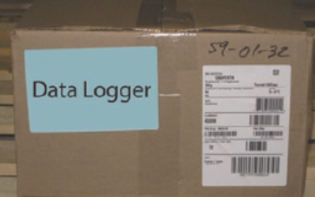

If the agreement does not specify the type of Data Logger to be used, the preferred model is:
TEMP TALE 4
  - Ensure each unit is programmed to record temperatures for the entire transit duration plus an additional 5 days.
- Minimum Data Logger Requirements:
- Air Shipments:
  - Minimum of 2 data loggers for the first 4 pallets
  - Add 1 data logger for every additional 4 pallets
  - Example:
    - 8 pallets = 2 + 1 = 3 data loggers
    - 12 pallets = 2 + 1 + 1 = 4 data loggers
- Ocean Shipments:
  - Minimum of 2 data loggers per container, regardless of container size
  - Place one logger at each end of the container
- All Data Loggers must be verified as active and functioning prior to placement in the shipment.
- The Consignment Data Logger Form must be completed prior to shipment.
- Refer to Exhibit 3 for the required format and submission process

LABELING REQUIREMENTS
Inner Case and Master Shipper Labels
- Label Dimensions:
  - Must be 102 mm x 154 mm (4 in x 6 in)
- Barcode Requirements:
  - Each barcode must be accompanied by its human-readable equivalent in alphanumeric text
  - Minimum font size for human-readable text: 6 pt
  - No boxes or borders are permitted around barcodes or labels
- Barcode Standards:
  - Acceptable symbologies: GS1-128 and GS1 DataMatrix
  - Barcodes must include:
    - Static data: GTIN (mandatory)
    - Variable data: Lot number, Manufacturing date (optional), Expiration date, Serial number (optional)
  - All barcodes must comply with GS1 specifications, including proper human-readable formatting
- Implementation Notes:
  - During the GS1 implementation period, Code-128 is required for all stakeholders, including manufacturers, distributors, and pharmacies
  - Barcodes must be scannable using standard equipment to ensure operational efficiency
- Design Flexibility:
  - Pharmascience allows some flexibility in the positioning and sizing of barcodes, lines, and text
  - However, the overall layout provided in this document must be respected
  - If any portion of the label cannot be produced as specified, the Vendor must contact Pharmascience to discuss potential impacts and alternative solutions

Detailed Label Attributes

- Owner
- Name of the product owner (Pharmascience or its client)
- DIN/NPN
- Drug Identification Number or Natural Product Number, if applicable
- Product Name
- Trade name, if applicable
- Product Strength and Format
- Storage Conditions (Critical)
- Clearly indicate applicable storage conditions
- UPC Code (Critical)
- Must use UPC-A format
- Batch Number (Critical)
- Barcode format: Code-128 (preferred) or Code 39
- Human-readable value should be placed to the left of the barcode
- Expiration Date (Critical)
- Barcode format: Code-128 (preferred) or Code 39
- Format: DDMMYYYY (e.g., 30042013 for April 30, 2013)
- Alpha-numerical format:
  - Above barcode: MMYY (e.g., AL13)
  - Below barcode: DD.MM.YYYY (e.g., 30.04.2013)
- Manufacturing Date
- Barcode format: Code-128 (preferred) or Code 39
- Same alpha-numerical format as expiration date
- Case Quantity
- Barcode format: Code-128 (preferred) or Code 39
- Alpha-numerical value should be placed to the left of the barcode, labeled as “Qté Caisse / Case QTY”
- SCC-14 Code (Critical)
- Barcode format: Interleaved 2 of 5 (preferred), or Code-128 / Code 39
- Must include:
  - Packaging type (e.g., case or drum)
  - Case number (e.g., 1 of 5, 2 of 5)
- GS1 DataMatrix (Critical)
- Must include GTIN (mandatory), Lot number, Expiration date, and other fields such as Manufacturing date and Serial number
- Must follow GS1 specifications for both barcode and alpha-numerical formatting

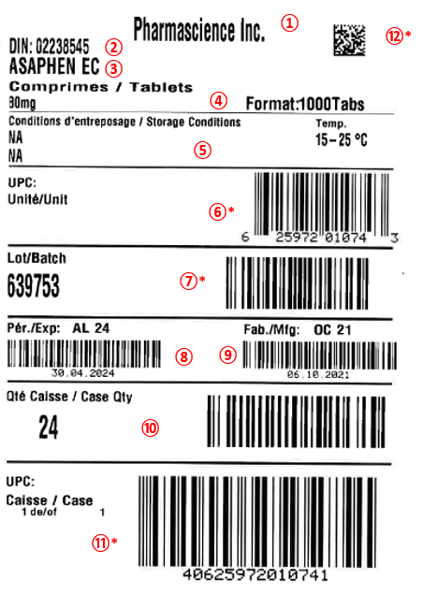

Shrink / Inner label specifications
- Label Dimensions:
  - Must be 63.5 mm x 76.2 mm (2.5 in x 3 in)
- Barcode and alphanumeric Information:
  - Each barcode must be accompanied by its human-readable equivalent in alphanumeric text
  - Minimum font size: 6 pt
  - No boxes or borders are permitted around barcodes or labels
- Label Placement:
  - The inner label must be applied directly over the shrink film of the packaging
- Accepted Barcode Symbologies:
  - GS1-128 and GS1 DataMatrix are both acceptable
  - Barcodes must include:
    - Static data: GTIN (mandatory)
    - Variable data: Lot number, Manufacturing date (optional), Expiration date, Serial number (optional)
  - All barcodes must comply with GS1 specifications, including proper alphanumerical formatting
- Design Flexibility:
  - Pharmascience allows some flexibility in the positioning and sizing of barcodes, lines, and text
  - However, the overall layout provided in this document must be respected
  - If any portion of the label cannot be produced as specified, the Vendor must contact Pharmascience to discuss potential impacts and alternative solutions
- Barcode Performance:
  - All barcodes must be successfully scannable using standard equipment

Shrink / Inner label- Detailed attributes:
Please note that customer-specific requirements may override the following format based on the product’s Master Specification. Vendors must ensure compliance with any client-specific labeling instructions.
Mandatory Label Elements
- Owner
  - Name of the product owner (Pharmascience or its client)
- Quantity
  - Number of units contained within the inner pack
- Expiration Date
  - Format: MMYY (e.g., FE10 = February 2010)
  - Must be clearly printed in human-readable alphanumerical format
- Batch Number (Critical)
  - Barcode format: Code-128 (preferred) or Code 39
  - Alphanumerical value should be placed to the left of the barcode
- Storage Conditions
  - Clearly indicate applicable storage requirements
- Inner SCC-14 Code (Critical)
  - Barcode format: Interleaved 2 of 5 (preferred), or Code-128 / Code 39
  - Alphanumerical value must be placed below the barcode
- GS1 DataMatrix (Critical)
  - Must include:
    - GTIN (mandatory)
    - Lot number
    - Expiration date
    - Optional: Manufacturing date, Serial number
  - Must comply with GS1 specifications, including proper alphanumerical human-readable formatting

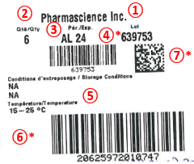

SHIPMENT SPECIFICS
Return to Vendor
- Pick-up of returned materials must follow the same protocols as standard deliveries:
  - Pick-up appointments are required at Pharmascience sites
  - A valid Return Purchase Order (PO) must be issued prior to pick-up
  - All commercial documentation for customs must be available at the time of pick-up
RUSH Shipments
- Only when explicitly requested by Pharmascience, materials designated as “RUSH” must be:
  - Clearly marked with a colored label stating “RUSH” on the shipper packaging
  - Given priority processing upon arrival at the receiving site

RECEIVING SITES PROCEDURES
Pharmascience operates multiple receiving sites, each with specific responsibilities:
- ROYALMOUNT: Receives packaging components, raw materials, and subcontractor returns
- DORVAL: Receives finished products
- CANDIAC: Site-specific procedures apply (details available upon request)

Delivery Coordination
- Carriers appointed by the Vendor are responsible for contacting the designated Pharmascience Receiver to schedule a mutually agreed appointment time
- Delivery must not proceed without confirmed appointment
- If scheduling conflicts arise, they must be escalated to the Warehouse Manager for resolution
Parcel Identification
- Each parcel must clearly display:
  - Purchase Order (PO) number
  - Vendor/Manufacturer batch number
Transport & Handling Requirements
To ensure materials arrive in optimal condition, the Vendor/Shipper/Carrier must:
- Maintain recommended storage conditions throughout transit
- Use a clean, well-maintained trailer, free of residue from previous deliveries
- Avoid loading materials with:
  - Food products
  - Odor-emitting items (e.g., perfumes, fragrances, spices)
- Do not double-stack pallets of packaged finished goods unless explicitly authorized by Pharmascience
- For full truckload deliveries, trailers must be sealed with a tamper-evident device
  - The seal must be broken in the presence of the Receiver upon arrival
- Include temperature recorders when shipping in temperature-controlled trailers

REMINDER- Non-Conformity Penalties
Failure to comply with the standards outlined in this handbook may result in monetary penalties. These penalties are applied to cover the cost of corrective actions required due to non-conformities, including but not limited to:
- Improper palletization of freight
- Re-labeling of shippers or bundles
- Rework of packaging to meet specifications
- Missing data loggers
- Non-compliance with required temperature conditions, including absence of thermo wrapping when applicable
Pharmascience will assess and apply penalties based on the nature and impact of the non-conformity. Vendors are encouraged to ensure full compliance to avoid delays, additional costs, and potential rejection of shipments.

EXHIBIT 1: ONLINE REFERENCE SITES

CUSMA CERTIFICATE OF ORIGIN: https://www.cbsa-asfc.gc.ca/services/cusma-aceum/cog-com-eng.html
Canada Customs Invoice: http://www.cbsa-asfc.gc.ca/publications/forms-formulaires/ci1.pdf
Canada Customs Tariff:
  - HS Code determination
  - https://www.cbsa-asfc.gc.ca/trade-commerce/tariff-tarif/menu-eng.html
Canadian Heat Treated Wood Products Certification Program (CHTWPCP): http://www.inspection.gc.ca/plants/forestry/imports/wood-packaging/eng/1361328825468/1361328931666
Guidelines for environmental control of drugs during storage and transportation (GUI-0069): https://www.canada.ca/en/health-canada/services/drugs-health-products/compliance-enforcement/good-manufacturing-practices/guidance-documents/guidelines-temperature-control-drug-products-storage-transportation-0069.html

EXHIBIT 2: INCOTERMS 2020

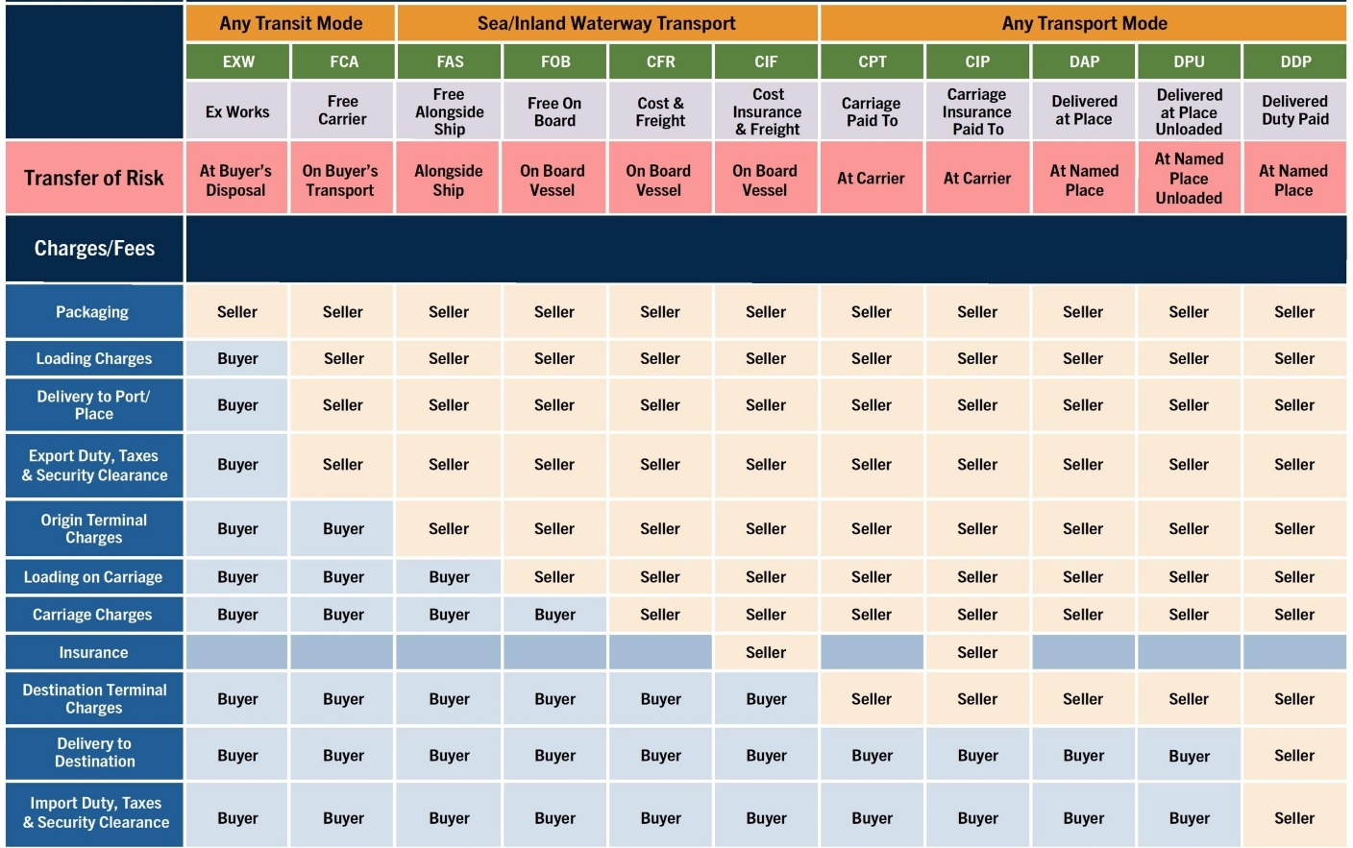

EXHIBIT 3: Consignment Data Logger Form
CONSIGNMENT AND DATA LOGGER DETAILS
To be filled by Subcontractor site before shipping the Goods

PO # / Invoice #
Storage condition during transportation | 15-30⁰C 2–8⁰C other:
Delivery from
Receiving location
DATA LOGGER DETAILS
No. of Data loggers
Model / Serial #
Calibration | Done on:  Next due date:
Data logger start time
Dispatch date
Data Logger placed in container # / pallet #
Vendor remarks (if any specific requirement):  Prepared by:  (Name & Date) | Vendor to sign & date:  Verified by:  (Name & Date)

1 Copy to be send with Invoice / PO
1 Copy to keep by Subcontractor

EXHIBIT 4: External SharePoint Collaborative Environment – Procedure and User Guide.

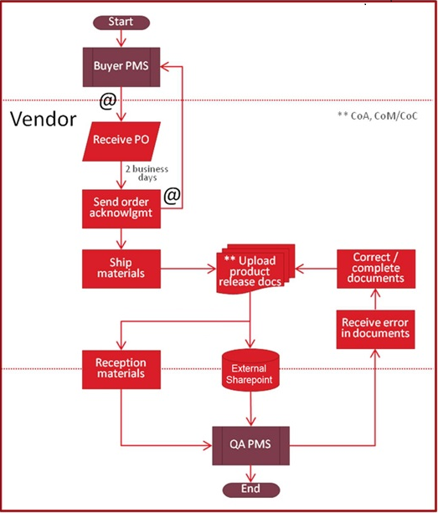

Connecting to the Collaborative SharePoint Site Procedure available on request:

